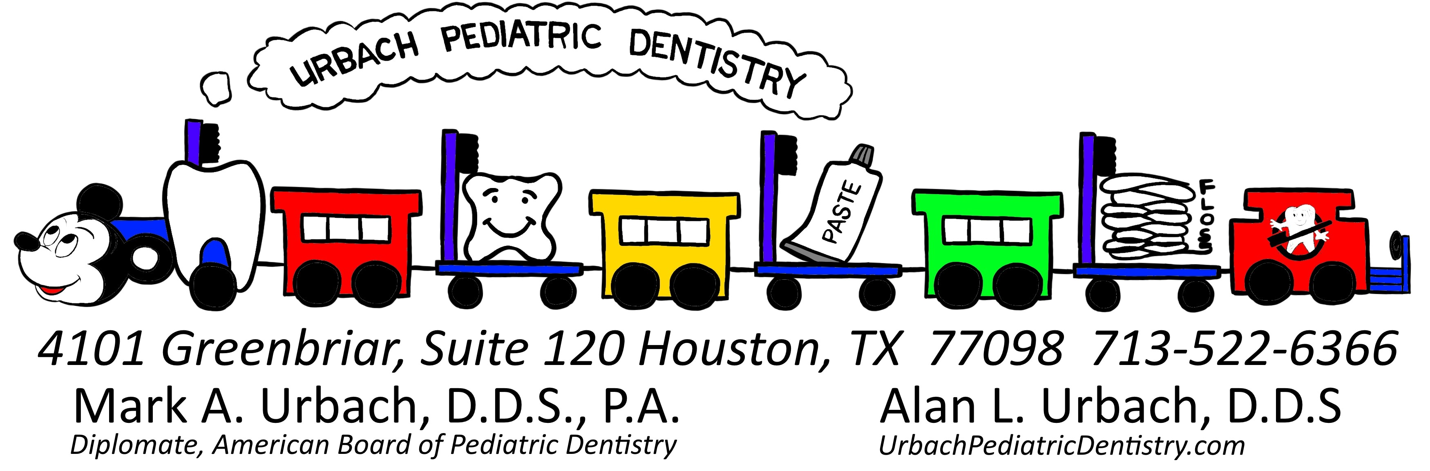
Returning Patient Information Form
*Due to new regulations, all information below needs to be updated at each visit*
Patient’s Name/s: _______________________________________________________________
Parent Name: ___________________________________________________________________
Cell: ________________________________Work:_____________________________________ Email: ________________________________________________________________________
Parent Name: ___________________________________________________________________
Cell: ________________________________Work:_____________________________________ Email: ________________________________________________________________________
Address: ______________________________________________________________________
City: ________________________________ State: _____________ Zip: _________________
Dental Insurance Information: Insured Name: _________________________________________ Insured Employer: ____________________________ Insurance Company: _________________
Insurance Address: _______________________ Insurance Number: ______________________
Social Security #: _________________ ID #: _____________________Group #: ____________ Insured DOB: ___________________ Relationship to Patient: ___________________________ If you have secondary insurance, Please ask for another form to list this information. If insurance does not pay within 30 days of treatment, or if the insurance is incorrect, you will be responsible for payment of full fees for services upon receiving a statement. You are also responsible for paying the estimated patient/ insured portion in full today.
Has your child’s MEDICAL HISTORY changed since the last visit? _____YES _____ NO
If so please list changes _________________________________________________________
I, ______________________, (please print) give my consent to Mark A. Urbach, D.D.S., P.A. or any member of his staff to perform one on the following procedures on my child/children: Please check the boxes below to anything this visit may contain. If not filled out correctly, it may delay treatment of your child.
___ Exam Only
___ Emergency Exam
___ Dental Xrays (Usually taken once a year unless needed)
___ Dental Prophy (Teeth cleaning)
___ Fluoride (Most insurance companies only pay once a year)
___ N20 (Nitrous Oxide or Laughing gas)
___ Sealants
___ Dental Restorations: ____ ALLOY (silver) ___RESIN (white or tooth colored) ___ Extractions
___ Stainless Steel Crowns and Nerve Treatment ____SILVER ____WHITE FACING ___ Papoose Board
___ OTHER: ______________________________________________________________
Signature of Parent/Guardian: _____________________________ Date: _____________
All Rights Reserved 2014 Urbach Pediatric Dentistry
Returning Patient Medical Information
Patient Name: ___________________________________________________ Date of Birth _____ / _____ / _____
Is your child being treated by a physician at this time (other than regular checkups)? [ ] YES [ ] NO Reason? _________________________________________________________________________________________
Is your child taking any medications (prescription or over-the-counter)? [ ] YES [ ] NO
List name, dose, frequency, date started: ____________________________________________________
___________________________________________________________________________________________________
Has your child had any illness, surgery, injury, allegic reaction, or medical emergency in [ ] YES [ ] NO the past year?
Describe: ________________________________________________________________________________________
Has your child ever had a reaction to or problem with an anesthetic? [ ] YES [ ] NO
Describe: ________________________________________________________________________________________
Has your child ever had a reaction or allergy to an antibiotic, sedative, or other
medication? [ ] YES [ ] NO
List: ______________________________________________________________________________________________
Have there recently been any significant changes /disruptions to your childs family,
home, or school routines? [ ] YES [ ] NO
Describe: ________________________________________________________________________________________
What is your primary concern regarding your child’s oral health? ______________________________________________
___________________________________________________________________________________________________
Has your child had any tooth pain or injury to the mouth/teeth/jaws since last
visiting our office? [ ] YES [ ] NO
Describe: _______________________________________________________________________________________
Has your child’s diet changed significantly since his/her last dental visit? [ ] YES [ ] NO Describe: _______________________________________________________________________________________
Has your child been treated by another dentist since last visiting our office? [ ] YES [ ] NO
Reason: _________________________________________________________________________________________
Is there any other change in your child’s medical, dental, or family history that the
dentist should be told? [ ] YES [ ] NO
Describe: _______________________________________________________________________________________
_______________________________ _____________________________ ____________
Name of Parent/Guardian Signature Date
All Rights Reserved 2014 Urbach Pediatric Dentistry

